Task 1:
Create a directory called ""my_folder"", navigate into it, and create a file named ""my_file.txt"" with some text. Then, create another file named ""another_file.txt"" with some text. Concatenate the content of ""another_file.txt"" to ""my_file.txt"" and display the updated content. Finally, list all files and directories in the current directory.
Cmds:
riyaz@ApsaraRiyaz:~$ mkdir my_folder
riyaz@ApsaraRiyaz:~$ cd my_folder/
riyaz@ApsaraRiyaz:~/my_folder$ vi my_file.txt
riyaz@ApsaraRiyaz:~/my_folder$ cat my_file.txt
Hi,
How are you?
riyaz@ApsaraRiyaz:~/my_folder$ vi another_file.txt
riyaz@ApsaraRiyaz:~/my_folder$ cat another_file.txt
I am good,
Thanks
How about you?
riyaz@ApsaraRiyaz:~/my_folder$ cat another_file.txt >> my_file.txt
riyaz@ApsaraRiyaz:~/my_folder$ cat my_file.txt
Hi,
How are you?
I am good,
Thanks
How about you?
riyaz@ApsaraRiyaz:~/my_folder$ ls -lart
total 16
-rw-rw-r-- 1 riyaz riyaz 33 Dec 21 07:47 another_file.txt
drwxr-x--- 6 riyaz riyaz 4096 Dec 21 07:47 ..
drwxrwxr-x 2 riyaz riyaz 4096 Dec 21 07:47 .
-rw-rw-r-- 1 riyaz riyaz 50 Dec 21 07:48 my_file.txt
riyaz@ApsaraRiyaz:~/my_folder$

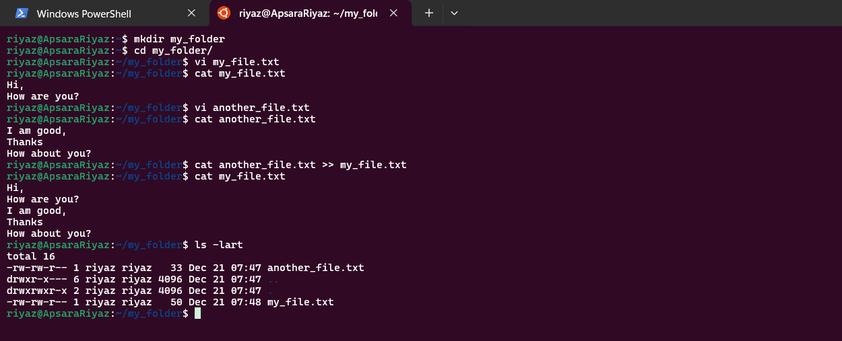

2. Task2:
Create 20 files with .txt extensions and rename the first 5 files to .yml extension and Print the latest created top 5 files among the total no of files".

